Parth Babbar

9999940289  kishibabbar@gmail.com

Financial inclusion initiatives in the us

**Financial Inclusion Initiatives in the US:**

**Introduction:**

Financial inclusion guarantees that individuals and companies have access to reasonably priced financial goods and services. It is critical for boosting economic growth and lowering social inequality. Despite the complexity of the US financial system, many Americans remain unbanked or underbanked, owing to factors such as geographic isolation and a lack of financial education.

**Historical Background:**

1. **Early 20th Century:** Credit unions were established as part of initiatives to offer underprivileged communities with inexpensive financial services.  
   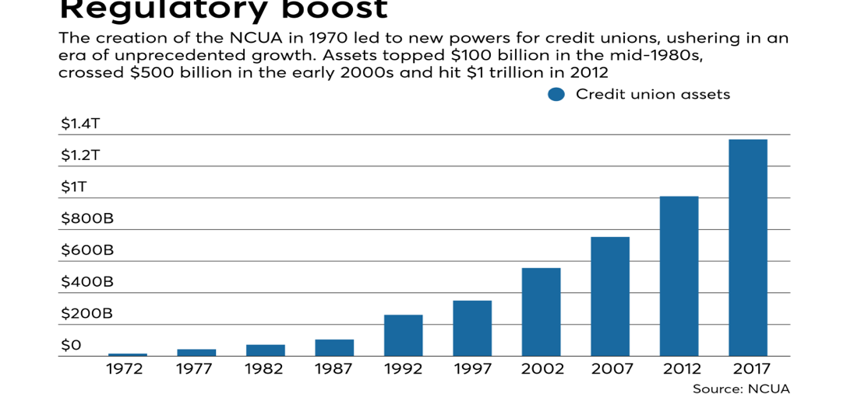
2. **1960s to 1970s:** The civil rights movement drew attention to the issue of financial exclusion, prompting legislative attempts such as the Community Reinvestment Act of 1977 (CRA).  
   
3. **1990s to 2000s:** Technological advancements and the advent of microfinance and fintech firms led to the development of new financial inclusion solutions.

**What is the current status of financial inclusion in US?**

According to the FDIC, around 5.4% of US families were unbanked in 2021, with another 18.7% underbanked, relying on alternative financial services such as payday loans and cheque cashing. Geographic limitations, particularly in rural and underserved urban areas, economic challenges, as traditional banking services can be prohibitively expensive for low-income individuals, and educational barriers, such as a lack of financial literacy, all impede effective use of banking services.

**What are the key Initiatives of Financial Inclusion?**

There are 3 major initiatives that are mentioned below:

1. **Government-led Initiative:** The Community Reinvestment Act (CRA) encourages banks to meet the credit needs of all communities, particularly those with low- and moderate-income populations, therefore fostering financial inclusion and equal access to banking services. The MyRA (My Retirement Account) Programme, on the other hand, was discontinued but was designed to provide simple and secure retirement savings options for low- and middle-income workers, addressing the pressing need for accessible retirement planning tools among underserved populations.
2. **Private-Sector Initiatives:** The Bank On Initiative works to guarantee that everyone has access to safe and cheap bank or credit union accounts, therefore promoting financial inclusion across various groups. Banks' financial literacy programmes complement this effort by providing excellent educational materials to assist consumers in properly managing their finances, improving their financial well-being, and fostering informed decision-making. Together, these programmes help to create a more financially inclusive society in which everyone have the skills and information they need to fulfil their economic goals.
3. **Non-Profit and NGO Initiatives:** The Centre for Financial Services Innovation (CFSI) conducts research, innovation, and collaborations to improve the financial health of marginalised communities, therefore creating positive change in the financial services industry and promoting economic stability and empowerment.

**Role of Technology:**

1. **Mobile-Banking and Digital Wallets:** Mobile technology enables consumers to access financial services without the need for physical branches, which is particularly significant in underserved regions.
2. **Platforms for Peer-to-Peer Lending:** These platforms offer alternative funding choices for people and small enterprises that may not be eligible for standard loans.
3. **Blockchain and Cryptocurrency:** These technologies have the potential to provide safe, low-cost financial transactions, notably remittances and cross-border payments.

**Conclusion:**

Financial inclusion programmes in the United States have made great progress, but problems persist. Addressing the digital gap, boosting cybersecurity, and increasing financial literacy are all key steps towards attaining complete financial inclusion. Future projects should prioritise using technology to reach disadvantaged people and offer them with the tools they need to manage their finances efficiently.